Tai White
Prof. Marino
10 May 2021
Performance and Revolution
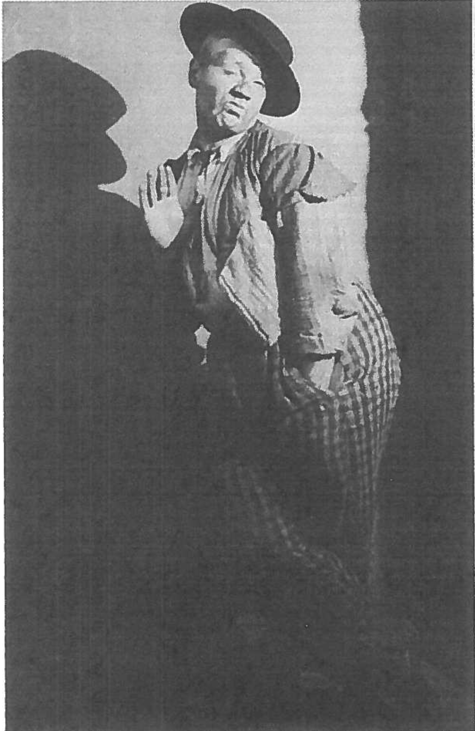
Meyerhold: The Lenin of Theater
The Bolshevik revolution was a period of dense intellectual progress. Explicit understandings of the state and class oppression were being developed rapidly through the dissemination of communist and socialist ideas in pamphlets, literacy projects, and through agitprop theater. These weren’t ideas of reform. Lenin envisioned a new and improved world order which would abolish the traditional bourgeoisie state and allow the proletariat state to “whither away” (Lenin, 4). Following Marx’s influential writings, Lenin claimed, “the existence of the state proves that class antagonisms are irreconcilable” (Lenin, 1).
This political revolution inspired a theatrical revolution. Vsevolod Meyerhold was a leader of this rebellion against traditional conceptions of theater. Meyerhold wrote extensively about how the approach to acting and embodying a character should be reformatted to create an efficient model of rapid production. Not only did Meyerhold develop methods of acting which reflected the ideals of the Bolshevik revolution, he also created shows that spread revolutionary rhetoric. This paper will examine how Meyerhold was inspired by the Bolshevik revolution, how he deployed his theory in his work, and how he was ultimately murdered by the state.
Meyerhold was trying to be the Lenin of theater. He developed his theory in “response to the demands of the new mechanized age, as opposed to [the theory] of Stanislavsky . . . which [was] unscientific and anachronistic” (Braun, 185). The traditional “inside out” approach to acting, where the player develops an internal connection to their character and circumstances to motivate action was incomplete in Meyerhold’s eyes, and couldn’t keep up with the rapidity of modern life. You could spend your whole life rummaging around in the psyche of a character but acting is labor so there needed to be a more efficient, and therefore humane way of executing the job. As a solution, Meyerhold suggested an “outside in” method for acting. He was all about biomechanics. He asserted that meaning is generated by the actor’s movement, and that movement should remind the audience of the skill and grace of a dancer. He said there should be “an absence of superfluous movements; rhythm; and the correct positioning of the body’s centre of gravity” (Braun, 198). He was focused on distilling the process of creating a performance into its purest, most intentional form, where the actor would choose a series of elegant, fluid movements that would create the clearest possible meaning for the audience. This rebellion against tradition was directly inspired by Lenin. Like Lenin, Meyerhold’s goal was to create efficiency and standardization. He believed that, “An actor working for the new class need[ed] to re-examine all the canons of the past” and that, “In the future the actor must go even further in relating his technique to the industrial action” (Braun, 197). He was consciously spreading revolutionary rhetoric to abolish old forms of theater and contribute to the dawning of a new world.
Meyerhold’s shows served as a vessel for his revolutionary passion. Embedded in his “outside in” theory is the idea that artists can internalize external events, like the Bolshevik revolution, and re-present them in their work. A prime example of this is Meyerhold’s repeated use of projected quotes from Lenin and Trotsky in his performances (Braun, 195-196). Another example is Meyerhold’s 1922 production, Tarelkin’s Death, which was “a barely concealed satire on Tsarist police methods” (Braun, 186). Yet another example is The Magnanimous Cuckold (1922), which employed a theory of “Constructivism” where the set was made from “utilitarian, multi-purpose scaffolding which could easily be dismantled and erected in any surrounding” (Braun, 184). This practice is in line with Meyerhold’s biomechanical approach to acting, and “his repudiation of naturalism and aestheticism” (Braun, 184). Again, Meyerhold believed in the revolution and labor’s possibilities for expression, so he found ways to practice and disseminate his beliefs through theater.
Meyerhold’s defense of avant-garde and experimental work ultimately led to his death at the hands of the Soviet Union. Meyerhold developed his theater practice in intellectual alignment with the ideals of Lenin, and the Bolshevik revolution, but because he “refused to submit to the constraints of artistic uniformity and defended the artist’s right to experiment,” he was arrested (Encyclopedia Britannica). In the end, he was accused of Trotskyism and spying for the Japanese, which he reportedly confessed to under torture. Meyerhold was sentenced to death in 1940 by firing squad, and yet, was posthumously cleared of all charges in 1955. This is the perfect microcosmic representation of the failings of the Soviet Union. In a genuine attempt to create community they began to force uniformity and created an authoritarian regime which repressed the very ideas that gave rise to the revolution.

Works Cited
Britannica, The Editors of Encyclopaedia. "Vsevolod Yemilyevich Meyerhold". Encyclopedia Britannica, 5 Feb. 2021, https://www.britannica.com/biography/V sevolod-Yemilyevich-Meyerhold. Accessed 11 May 2021.

Course Material:

Lenin, Vladimir. The State and Revolution (link here).
Reading: Edward Braun (ed.), Meyerhold on Theatre, pp.159-206. (pdf)

