When Politics Became Theater, and how Theater can save Politics
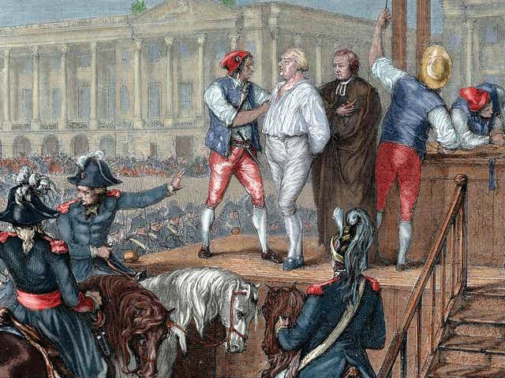
A print from La France et les Français, artist unknown
The creation of a new government is one of the most significant parts of a revolution. After creating a blank slate, the way a new government is implemented speaks to the wishes of the people and their frustrations with the previous government. The French Revolution is no different—after removing King Louis XVI from power, revolutionaries strove to create a government that was accountable and transparent, unlike the reign of the monarchy. However, intention rarely translates perfectly into practice. Despite their original motives, French revolutionaries created a political structure that strongly mirrored France’s surviving cultural institution—the theater.
Prior to the French Revolution, ultimate political authority in France belonged to the King. Because the King’s right to rule came from God, he did not need to justify the decisions he made. For this reason, politics were not a public debate. Trial verdicts, political alliances, and laws were crafted behind closed doors, without any involvement or observation from the people. This is not to say that the royal family didn’t appear in public. The King and other members of the aristocracy made public appearances during parades, when going to the theater (where other audience members were expected to watch and imitate them), and during other highly-staged spectacles. King Louis XIV would even perform in ballets, where he was depicted as Apollo the Sun God. The French Royalty practiced both politics and theater, but as a general rule, they conducted them separately. All of this changed with the implementation of a new government during the French Revolution. Due to their dissatisfaction with the monarchy, revolutionaries pushed for a representational government that answered to the people, not God.
In constructing this new government, one of the primary intentions of the revolutionaries was to create a highly accountable government. This government served the people, after all—so the people should be able to understand the decisions representatives were making, and remove them from power when desired. Politicians were expected to be genuine and transparent, traits that actors were commonly accused of lacking. Philosopher Jean-Jacques Rousseau, in an open letter protesting the theater, called actors “servile and base”, and criticizes them for “saying what [they do] not think as naturally as if [they] really did think it”. This is not to say that all political figures and philosophers disliked the theater. In fact, several key members of the French Revolution had acted in the theaters professionally (Maslan 15). Still, there was a consensus among revolutionary leaders that the new government officials should be genuine and decent. In her book Revolutionary Acts, Susan Maslan writes:
“In politics and theater, revolutionaries sought, in very different ways, to create a regime of transparency, a regime in which all hearts and souls communicate perfectly and without obstacles. The threat posed by theatricality was the threat of opacity, the threat that something in the guise of transparency had the potential to alienate politicians from those in whose name they spoke and, even worse, to alienate citizens from themselves and from each other” (4).
Throughout the formation of a new French government, revolutionaries strove to separate the perceived immorality of the theater with the transparency they hoped for their politics.
Despite revolutionaries’ best intentions, their attempts to create a highly representative governmental system led to the need for theatrical politicians. The desire to hold politicians accountable meant that those same politicians had to act in the interest of self-preservation, even if it meant “saying what [they do] not think as naturally as if [they] really did think it” (Rousseau, while voicing his dislike for actors). During the French Revolution, political figures were frequently put on trial and guillotined. Even Robespierre, a primary supporter of guillotining anyone who expressed anti-revolutionary sentiment, was eventually executed. A system where sharing a particular opinion means you could be killed by its very nature will lead people to say things and act in ways they do not truly believe. No example illustrates this better than the trial of Marat, who nominated himself to appear before the Revolutionary Tribunal, and, when indicted, “seemed to be delighted with the result” (Gérard Walter, quoted by Huet). Despite the fact that he put himself up for trial, spectators appeared in order to voice their support for Marat. When on the stand, Marat made a show of defending himself against his opposition and publicly justifying his decisions and actions (Huet). Marat’s self-incrimination and positive reaction to being given the chance to appear in a trial shows that these proceedings were not for their intended purpose—to prove someone guilty or innocent—but rather for Marat to perform his innocence in front of his peers and the Parisian citizens. Moreover, when he was found innocent, it gave Marat a degree of protection from his own actions. They could no longer be used as political arguments against him, now that he had formally been proven innocent by the Revolutionary Tribunal. Marat clearly understood the need for creating appearances as a political figure, and his actions demonstrate the way the French political system was ideally situated to create performers of politicians.
In addition to self-preservation, politicians were also motivated towards theatrical tendencies because of the similarities created between the theater and politics. Because of the desire for citizens to be able to observe and express judgement of their representatives, politics became a spectator sport. During the trial of King Louis XVI, spectators “hooted, jeered”, and otherwise engaged with the proceedings (Louis-Sébastien Mercier, quoted by Huet). Other theaters in Paris were closed, because they knew that the trial would compete with attendance at the theater. Louis’s trial was a form of entertainment and spectacle, in addition to the practicing of law. This instinct to view political proceedings as theater was buoyed by the practices of the Parisian theater prior to the Revolution. The citizens, lacking the ability to see the king making decisions or verdicts, turned to theatrical representations of those events. In the years prior to and during the French Revolution, theater served as a sort of “moral propaganda” for the revolution, reinforcing the messages spoken by revolutionaries and encouraging a more pro-revolutionary mindset. Is it any surprise, then, that the people so easily transitioned from representation to the real thing? While the Revolution changed many things, the habit of attending spectacles—whether that spectacle was a play or an execution—remained.
In spite of the intentions of many, the government created after the fall of the French Monarchy during the French Revolution created a political atmosphere full of theatricality. Thanks to the established Parisian theater tradition, the pressure on politicians to act in self-preservation, and the need for political accountability, politicians became public figures who had to perform their duties, not just accomplish them. As one of the first representative models of government attempted in modern Western society, this precedent of the political “stage” has endured, and continues in most governments today. We are still striving to overcome the same issues as French revolutionaries—how do we create honest, transparent government officials that are still responsive to the wishes of the public?
If theatricality is a weapon politicians use to control the people, so too must theater be a tool of the people to control politicians. “Image is everything”, as the famous aphorism goes, and so the only tool against politicians performing their jobs is to use media to show the negative side to their actions. As artists, journalists, and cultural influencers, it is our responsibility to keep politicians in check. Ultimately, a government more responsive to the wants of the people will reward politicians who put on a good show. Since there is no way to take the theater out of politics, we must instead use the theater to shape our politics in ways that are honest, unbiased, and help illuminate politicians for their true impact on the world.

